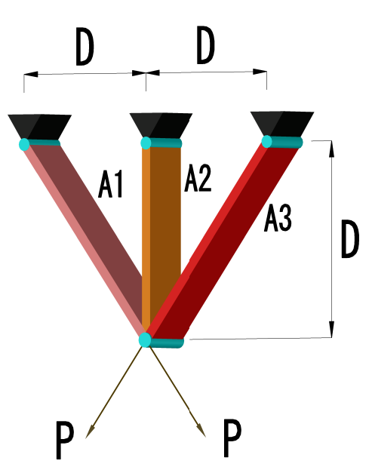

|  |  |  |  |  |  |  |
| --- | --- | --- | --- | --- | --- | --- |
|  | Optimal values for variables | | Best Subjects | | | Optimal Cost |
| Algorithm | x_(1) | x_(2) | g_(1) | g_(2) | g_(3) | f(x) |
| **H5N1** | **0.78841447** | **0.4081158** | **0.000659381** | **-1.4639226** | **-0.53541802** | **263.8523464** |
| PSO-DE[3] | 0.7886751 | 0.4082482 | -5.29 E-11 | -1.4637475 | -0.5362524 | 263.8958433 |
| SSA[1] | 0.7886654 | 0.4082758 | N/A | N/A | N/A | 263.8958434 |
| DEDS[2] | 0.7886751 | 0.4082483 | 0.0000000 | -1.4641016 | -0.5358984 | 263.8958434 |
| Ray[5] | 0.7886210 | 0.4084013 | N/A | N/A | N/A | 263.8958466 |
| MBA[4] | 0.7885650 | 0.4085597 | -5.29 E-11 | -1.4637475 | -0.5362524 | 263.8958522 |
| Ray & Saini [6] | 0.7950000 | 0.3950000 | N/A | N/A | N/A | 264.3000000 |

[1] S. Mirjalili, A. H. Gandomi, S. Z. Mirjalili, S. Saremi, H. Faris, and S. M. Mirjalili, “Salp Swarm Algorithm: A bio-inspired optimizer for engineering design problems,” *Adv. Eng. Softw.*, vol. 114, pp. 163–191, Dec. 2017, doi: 10.1016/j.advengsoft.2017.07.002.

[2] M. Zhang, W. Luo, and X. Wang, “Differential evolution with dynamic stochastic selection for constrained optimization,” *Inf. Sci.*, vol. 178, no. 15, pp. 3043–3074, Aug. 2008, doi: 10.1016/j.ins.2008.02.014.

[3] H. Liu, Z. Cai, and Y. Wang, “Hybridizing particle swarm optimization with differential evolution for constrained numerical and engineering optimization,” *Appl. Soft Comput.*, vol. 10, no. 2, pp. 629–640, Mar. 2010, doi: 10.1016/j.asoc.2009.08.031.

[4] A. Sadollah, A. Bahreininejad, H. Eskandar, and M. Hamdi, “Mine blast algorithm: A new population based algorithm for solving constrained engineering optimization problems,” *Appl. Soft Comput.*, vol. 13, no. 5, pp. 2592–2612, May 2013, doi: 10.1016/j.asoc.2012.11.026.

[5] T. Ray and K. M. Liew, “Society and civilization: An optimization algorithm based on the simulation of social behavior,” *IEEE Trans. Evol. Comput.*, vol. 7, no. 4, pp. 386–396, Aug. 2003, doi: 10.1109/TEVC.2003.814902.

[6] T. Ray and P. Saini, “ENGINEERING DESIGN OPTIMIZATION USING A SWARM WITH AN INTELLIGENT INFORMATION SHARING AMONG INDIVIDUALS,” *Eng. Optim.*, vol. 33, no. 6, pp. 735–748, Aug. 2001, doi: 10.1080/03052150108940941.